**Farmer Notification**

Here everything is connected to each other through a WIFI module. This gives the farmer the opportunity to become aware of the ups and downs of the water in the paddy field. When the volume of the water is high, its sensor control its action. It’s a great convenience to the farmer.

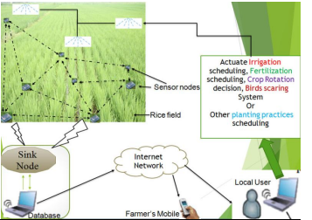

Connect true the internet

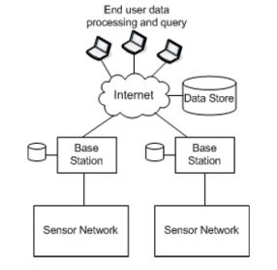

System Diagram

<https://www.ripublication.com/ijaer17/ijaerv12n18_33.pdf>